**Capstone Project - The Battle of Neighborhoods**

**Opening Middle Eastern Restaurant in Ottawa (Canada)**

**1. Introduction**

**1.1 Background**

* **About Ottawa:**

Ottawa is Canada’s capital, in the east of southern Ontario, near the city of Montréal and the U.S. border. Sitting on the Ottawa River, it has at its center Parliament Hill, with grand Victorian architecture and museums such as the National Gallery of Canada, with noted collections of indigenous and other Canadian art. The park-lined Rideau Canal is filled with boats in summer and ice-skaters in winter.

Ottawa is the nation’s capital and the fourth largest urban region in Canada. It includes over 1.4 million people, 66% of whom live in Ottawa and the rest in neighboring municipalities, including Gatineau (located across the Ottawa River in Quebec). A special feature of the region is that both English and French are widely spoken and reflected in the City’s culture and commerce.  Ottawa is also [multicultural with a large and growing immigrant population](https://ottawa.ca/en/city-hall/budget/financial-reports-and-statements/long-range-financial-plans/long-range-financial-plan-iii-part-1-and-part-2/economy-and-demographics) that enriches the city.

* **About Economic:**

On the economic front, Ottawa is a major economic engine, offering jobs and opportunities in high tech industries, government, and important sectors such as health and education. The City is home to world- class research centers, top notch academic institutions and operations by major international companies.

**1.2. Problem**

In this project, I will investigate that if there is any good location in Ottawa for opening Middle Eastern restaurant,

And should I open an Middle Eastern restaurant restaurant to have the best chance of being successful?

**1.3. Interest**

Anyone who wants to open a new venue in any geographic location may be interested in this project by modifying search criteria.

**2. Data**

**2.1 Data sources**

To consider the problem we can list the data as below:

* I get the neighborhood data of Ottawa from Google Search.
* I will use python geocoder library to get geographical coordinates of neighborhoods.
* I will use **Foursquare API** **venues explore** method to get the venues of given neighborhoods of Ottawa.
* I will use **Foursquare API venues method** to get ranks and likes of restaurants by given venue id.

**A. References:**

* [1] [Ottawa - Google Search](https://www.google.com/search?biw=1536&bih=700&ei=Q_-qXqWTJYHjgweflKHQBQ&q=ottawa+neighbourhoods&oq=ottawa+ne&gs_lcp=CgZwc3ktYWIQARgEMgQIABBDMgIIADICCAAyAggAMgIIADICCAAyAggAMgIIADICCAAyAggAOgQIABBHOgUIABCRAjoFCAAQgwFQh5HCBlibo8IGYMe8wgZoAHAEeACAAdwBiAG-CpIBBTAuOC4xmAEAoAEBqgEHZ3dzLXdpeg&sclient=psy-ab)
* [2] [Ottawa Ranking Communities](https://www.macleans.ca/best-communities-canada-2019-full-ranking-tool/)
* [3] [Python Geocoder Library](https://geocoder.readthedocs.io/)
* [4] [Foursquare API](https://developer.foursquare.com/)

**2.2 Feature Selection and Data Usage**

I will use neighborhood location values to analyze Ontario geographical structure. I will use folium library of python to draw maps by using given latitude and longitudes of neighborhoods. Selected features will be as below

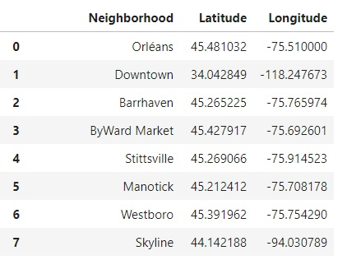

I will also classify neighborhoods by using venues distribution and counts. In this way, I will find similarities of neighborhoods which will help me to choose location for opening a new restaurant. Similar structured neighborhoods may handle same type of venue.

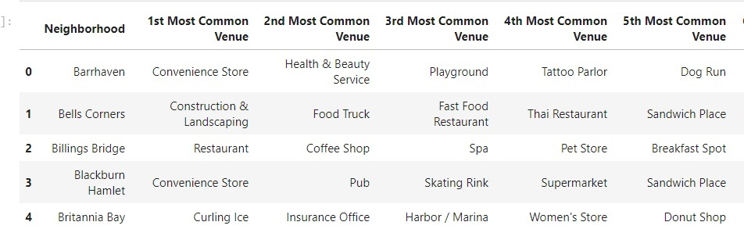

I will use venue list category to find distribution of restaurants and Middle Eastern restaurants in neighborhoods.

